2026 Update: Closing the Infrastructure Gap

Background
In 2023, AFN published Closing the Infrastructure Gap by 2030, a comprehensive cost report that quantified the capital and operating investments required to close the First Nations infrastructure gap in Canada. The report estimated the investment need at $349.2 billion in nominal dollars from 2023 to 2030, reflecting decades of underfunding, unmet fiduciary responsibilities, and inequities in the distribution of Canada’s infrastructure investments.
With the 2030 deadline rapidly approaching, the AFN has updated the cost estimate to a 10-year forecast based on more recent escalation factors to inform federal budget decision-making.

Methodology
This update used the needs estimates from the original CTIG studies, incorporated estimated funding from the Government of Canada towards the gap, and applied escalation factors to reflect the increased costs of construction over time (including inflation). The new estimate would see the infrastructure gap close by 2036.
The escalation of prices relied on the Building Construction Price Index (BCPI) for residential and non-residential construction and its relationship to inflation overall. For the forward projection, the escalation assumes that BCPI annual increases will slowly decline and return to align with inflation by 2030 and then remain constant.

The updated assessment also re-categorised costs into a reduced number of categories to align with how infrastructure categories are managed and funded by the Government of Canada. These six service lines include water and wastewater, housing, education, health, other community infrastructure and off-reserve infrastructure. One of the most significant changes is the transition of all water- and wastewater-related infrastructure to the water service line. While the original CTIG water category included only the estimated cost to end 33 drinking water advisories, it now also includes the infrastructure needed for all water and wastewater infrastructure. The figure below displays how the previous categories align with the new service lines used in this analysis.
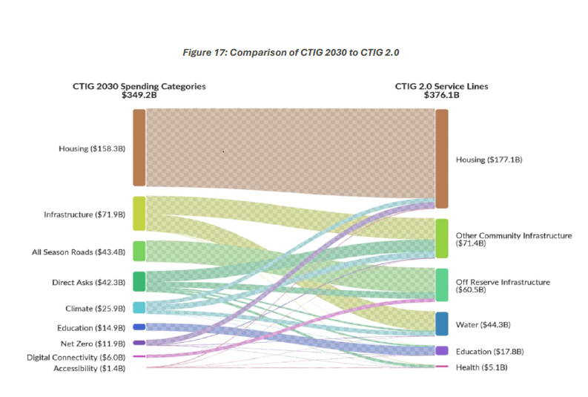

Findings
Despite commitments from the Government of Canada to close the infrastructure gap, the gap has continued to grow. The AFN's updated analysis has found that despite increases in funding since 2022, the gap has grown from $349.2 billion to an estimated $376.1 billion (both reported in nominal dollars). This updated costing includes an estimated $33.4 billion that went towards the gap between 2020 and 2027.
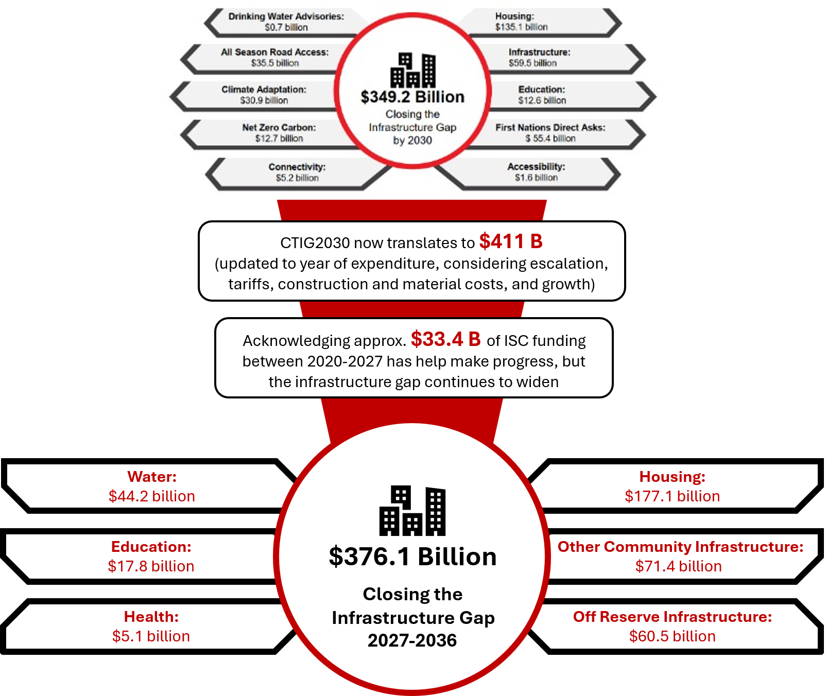

The real cost of closing the gap still likely exceeds this estimate. This updated analysis assumed price increases over time will return to regular inflation, an assumption that could be complicated by the cost impacts of extended international conflict and the uncertainty of US tariffs. This updated estimate does not include the added costs over recent years of deterioration due to lack of maintenance, wildfires, floods and other climate emergencies causing significant damage to communities across Canada, and the increasing need for additional land as First Nations outgrow the size of their communities due to growing population and migration back to reserve.
Closing the infrastructure gap will require a whole-of-government approach, a removal of barriers that slow and prevent First Nation construction, and a process that supports First Nations governance, self-determination and decision making. While government support and funding are crucial to closing the gap, policies and funding must be designed through First Nations-led processes. First Nations leadership are the experts in what is need in their communities, however, many programs are designed with First Nations as an afterthought. This type of policy design will never close the gap.
The estimated economic benefits of closing the gap are 1.82 per dollar invested, however, this only scratches the surface of the health, social, and generational benefits of closing the gap. The infrastructure gap stands as a quantified measure of the impact of colonial policies in Canada. Without closing the gap, First Nations will continue to be overrepresented in the health care system, the child and family services system, incarcerated population, and people experiencing homelessness. Closing the infrastructure gap is vital to improving First Nations socio-economic outcomes and reconciliation.

Conclusion
The update to CTIG confirms that the First Nations infrastructure gap continues to grow despite increased funding, although the pace of growth has declined. The lack of progress towards closing the gap reflects the persistent structural challenges in how infrastructure is planned, funded, and delivered. The updated analysis reinforces that progress is constrained by federal legislation, reserve creation, funding, and policy that is fragmented across public systems, misaligned with asset lifecycles, and insufficiently grounded in First Nations rights and governance.

