First Nations’ Climate Lens
Assembly of First Nations (AFN) Environment Sector

Video: First Nations Lens to Climate Action - YouTube

A First Nations’ Climate lens advocates for a fundamental reframing of the climate discourse; it moves away from the overemphasis on technological solutions, towards a framing that emphasizes the centrality of First Nations’ governance, rights and knowledge systems. This proposes that a critical and decolonizing lens is essential for equitable, immediate and transformative action built on solutions that are holistic, multi-dimensional and interconnected.
To better understand this reality, and advance First Nations climate solutions, the AFN has developed the concept of a First Nations “Climate Lens” (Figure 1). This Lens challenges conventional conceptualizations of First Nations as “vulnerable” populations and “passive recipients” of climate impacts. Indeed, our unique connections to the land, water, air, and non-human beings have enabled us to live reciprocally and in balance with all of Creation, providing a unique source of strength, understanding and resilience.
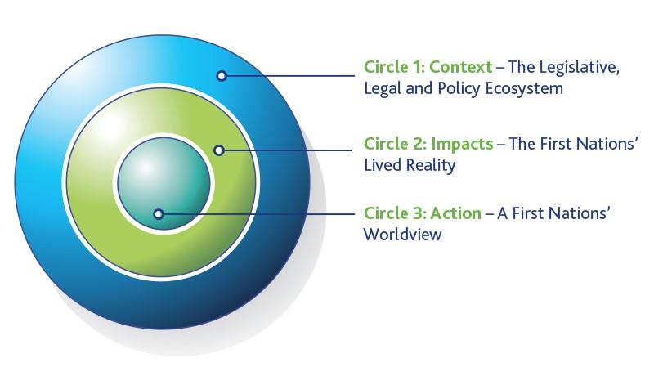

Circle 1: Context – The Legislative, Legal and Policy Ecosystem: For First Nations, climate action is a right- and responsibilities- based activity that occurs within a legislative, legal, and policy context. This stems from our inherent jurisdiction over our lands and territories, as well as our affirmed right to self-determination. The broader ecosystem for this includes the federal government’s commitment to pass legislation to implement the United Nations Declaration on the Rights of Indigenous Peoples (UN Declaration), to implement the Truth and Reconciliation Commission’s Calls to Action, and the Calls for Justice from the National Inquiry on Missing and Murdered Indigenous Women and Girls, as well as Indigenous-specific jurisprudence and the protections afforded to First Nations by the Constitution Act, 1982.

Circle 2: Impacts – The First Nations’ Lived Reality: In Canada, climate conversations often disregard the historical legacy of colonization, which has included relocating First Nations, forcibly removing children from their families, and placing them in Residential ‘Institutions’, and prohibiting the use of traditional languages and practices, among other atrocities. Climate change exacerbates many of the resulting impacts of colonization, including those relating to mental health and well-being, poverty, poor housing, food and water insecurity, and the erosion of rights, culture, and access to lands. The lived reality of First Nations needs to be understood and incorporated into analyses of the distribution and experience of climate-related impacts. In this regard, addressing the climate crisis cannot be separated from the broader project of First Nations self-determination and reconciliation.

Circle 3: Action – A First Nations’ Worldview: First Nations-led solutions are multidimensional, interrelated, interconnected, and grounded in First Nations law, knowledge, language, and governance. The core of a First Nations worldview is an understanding that we are one with the land. This recognition lays the foundation for a set of legal principles and orders that, while unique to each individual First Nation, represent natural, spiritual, and environmental law. It is this sacred responsibility that continues to guide how First Nations interact with, protect, and respect Mother Earth.

This Climate Lens challenges conventional conceptualizations of First Nations as ‘vulnerable’ populations and ‘passive recipients’ of climate impacts. Indeed, our unique connections to the land, water, air, and non-human beings have enabled us to live reciprocally and in balance with all of Creation. The cultural, spiritual, and social connection to the land may increase First Nations’ exposure and sensitivity to climate change impacts, but it also provides a unique source of strength, understanding and resilience. It stresses the fact that First Nations are climate leaders and, as such, are active drivers of positive change.

