Elsipogtog First Nation Education Authority Inc.

Strategic Plan

2021-2025

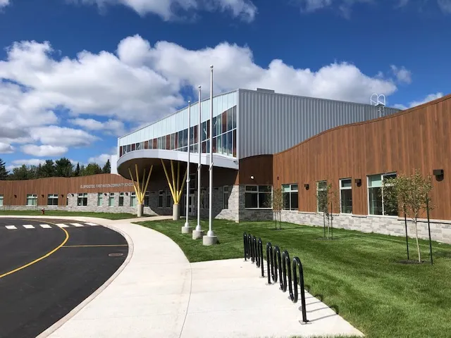

A successful life-long learning rooted in Mi’kmaq Language and Culture.

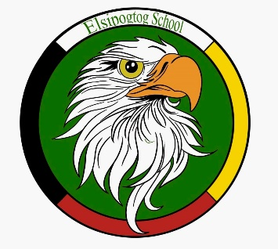

Introduction

Government of Canada signs Regional Education Agreement with Elsipogtog First Nation Education Authority

March 9, 2021 — Elsipogtog First Nation, unceded traditional Mi'kmaq territory, New Brunswick — Indigenous Services Canada
The Government of Canada is committed to First Nations education transformation that is inclusive and responsive to the diversity of Indigenous Peoples.
Today, the Honourable Marc Miller, Minister of Indigenous Services, and Chief Arren Sock announced the signing of the Regional Education Agreement (or REA) with Elsipogtog First Nation Education Authority, the first of its kind in Atlantic Canada.
In the coming weeks/months, Elsipogtog First Nation will establish its own education structure that will focus on better supporting cultural connections and diversity, responding to the unique needs of First Nations students and promote success for all.
Through this Agreement, Elsipogtog First Nation Education Authority is formalizing its partnership and funding relationship with Canada. The Agreement also commits to both parties to explore new ways to further improve education outcomes and address funding needs for special education for students of Elsipogtog First Nation.

Quotes
“The signing of this Agreement with Elsipogtog First Nation Education Authority is an important step that further supports the principle of First Nation control of First Nations' education. We congratulate Elsipogtog First Nation on the establishment of its own education structure to better address the needs of students for generations to come.”
-The Honourable Marc Miller
Minister of Indigenous Services

"The Education team, led by Ivan Augustine, has kept myself and Council apprised of their Regional Education Authority activities for the past 3 years. I am very pleased with the end results and the empowerment of the community in determining the educational future of our young people."
-Arren Sock
Chief of Elsipogtog First Nation

“It is with great pride and satisfaction that I acknowledge our education team in achieving REA status. This allows us to develop our education program in a manner which addresses the needs of our students and provides sustainable, predictable funding through our partnership with Canada.”

-Ivan Augustine
Director of Education, Elsipogtog First Nation Education Authority Inc.

Quick facts
- Elsipogtog First Nation is located eight kilometres southwest of Rexton, New Brunswick, on the Richibucto River. The community's total population of approximately 3,400 people includes 2,628 people that live on the reserve.
- The Elsipogtog First Nation Education Authority offers education services to the students of Elsipogtog First Nation, one of the three largest per capita First Nations in New Brunswick.

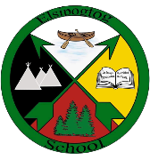
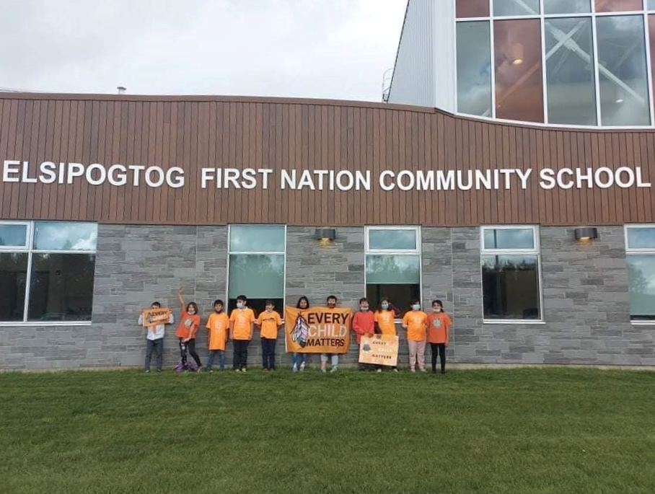

EFN Education Authority Inc. Operational Plan

2021-2025

1 Purpose of the EFN Education Authority Inc. Operational Plan
The purpose of the EFN Education Authority Inc. Operational Plan is to understand:
- Where we were?
- Where we are now?
- Where we want to be?
- How do we get there?
- How do we measure our progress?

2 Where we were?
In 1969 the federal government introduced the White Paper Policy. The 1969 White Paper (formally known as the “Statement of the Government of Canada on Indian Policy, 1969”) was a Canadian government policy paper that attempted to abolish previous legal documents relating to Indigenous Peoples in Canada, including the Indian Act and treaties. As a response by First Nations, the Red Paper policy was brought out by the National Indian Brotherhood and in this document, education was addressed. Indian Control Over Indian Education was born. This document with revisions made over the years has been the driving force in education of First Nation children. Prior to 1984, Elsipogtog Education was under federal control with the Minister of Indian Affairs being the sole decision maker of education policy. In 1985 the Elsipogtog First Nation Band took control of it its education system. Education of children fell to the control of Chief and Council with parental input. Band control of Indian Education struggled the first few years but was able to gain traction once partnerships were struck with the local provincial school district and the provincial Department of Education.

3 Where are we now
Band control continued to improve and gain positive results. Federal government has made many changes to education over the years, one being the introduction of the Federal Education Act for First Nations in 2014. This policy died as resistance grew from the grass roots. In 2017 the federal government introduced Transformation of First Nation Education. This model would be based on provincial comparability and First Nation communities can negotiate Regional Education Agreements (REA) on individual community basis with the Federal government. Elsipogtog First Nation Education chose this path and has successfully negotiated with the Federal government a 5-year Regional Education Agreement signed in 2021. We have developed new policies in critical areas for the organization to be successful through consultants. These administrative policies include a new:
- Human Resource Policy
- Financial Policy
- Governance Policy
- Administration Policy
- IT Policy
- Post-Secondary Policy
We are in development of an organization web site to inform our stake holders, the community, and partners of our progress.

4 Where we want to be
Priority: To achieve strong governance for the EFN Education Authority Inc.
Where Do We Want to Be? At the end of the signed EFN Education Agreement, we want to be in a very strong position with new polices finalized and put into practice. We want to achieve this by having our regular administrative and board meetings and adopting polices after they have been given final approval by the Board of Directors.
We want our organization to be fiscally responsible, transparent and accountable. We want the EFN Education Authority Inc. to be strong in these areas as it prepares for another round of negotiations for a second REA and the eventuality of the start of talks/discussions with Crown Indigenous Relations and Northern Affairs Canada (CIRNAC) on sectorial self-government in Education for Elsipogtog First Nation. We hope to expand on some of the initial communication with CIRNAC that presently exist.
Priority: As a First Nation Education Authority our highest priorities is educating school aged children at the Elsipogtog FN Community School. Our priorities are Mikmaq Language revitalization and Culture, Literacy, Numeracy, Science, and the success, growth, and support of High-Cost Special Education children.

5 How do we get there
Where Do We Want to Be? As a school we want to show over time through data by various measuring tools the success of school age children. With our Mikmaq conversational language immersion program at K4, we want to see a solid foundation of authentic conversational Mikmaq, a solid foundation in the mother tongue. Intensive Mikmaq language in early elementary grades and a strong language program and a strong culture program in the upper elementary and middle school levels. In Literacy, Numeracy, and Science we want to achieve or exceed provincial expectations. We will be able to track and show growth of children over time who have been exempted from writing provincial assessments by measuring tools available at school.

Vision, Mission, Values, Objective and Goals:

Elsipogtog Education Authority is committed to providing access to a high-quality education that inspires all students to achieve their full potential as life-long learners that reflects the community’s Mikmaq language, culture, values and traditions.

Self Determination
Mi’kmaq Language Declaration

We, the Mi’kmaq Peoples have spoken our Mi’kmaq language since time immortal, and we are responsible for the protection, revitalization, and advancement of our Mi’kmaq language.

Vision:

Every Elsipogtog student will graduate with the skills and understanding to lead a successful and responsible productive life. A successful holistic life-long journey rooted in Mi’kmaq language and culture.

Mission:

To provide a quality education in a safe and caring environment by revitalizing the Mi’kmaq language and culture, promoting respect, responsibility, skill development and an understanding of the Mi’kmaq unique traditions in partnership with students, families and the community.

Values:

• All children have the ability to learn and the right to an education that cultivates their gifts and reflects the traditions of the Seven Sacred Teachings.
• Working in partnership with parents so that all children reach their full potential and recognize their unique talents to become wise, thoughtful, and caring adults who are also lifelong learners.
• That children learn most effectively when teaching and curriculum are relevant to their own backgrounds, interests, and learning styles.
• That Mikmaq education must include the elders and reflect the language, traditions, culture, and values of the community.

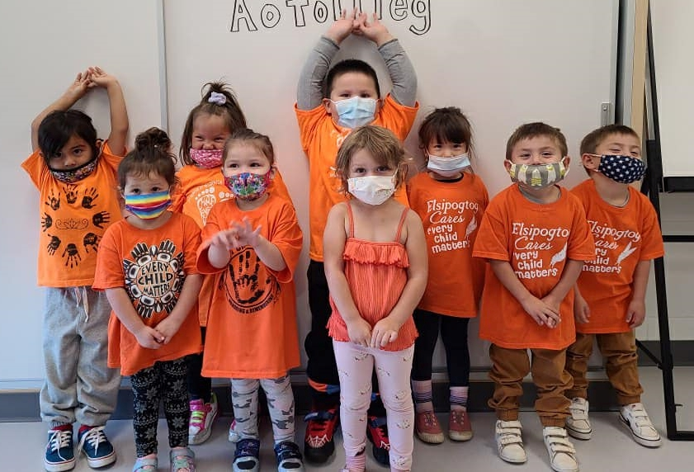

7 Sacred Teachings
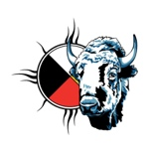Respect. Respect is the gift from the Buffalo. In all life respect is the first and foremost. Respect oneself and respect will be bestowed, for example, if you treat your body with respect, it will look after itself. If you treat it with poison, it will destroy itself.

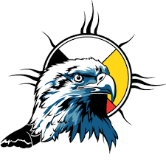Love. Love is the gift from the eagle. Love is a force that is undeniable. With love all things are possible, it is everyone’s right to have an experience it, in terms of the medicine wheel love is in the hub it is the symbolic of fire and the creator. Man is incapable of understanding the creator, so in turn he gave us a way to experience love and enjoy love through our children.

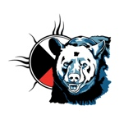
Courage. Courage the bear carries courage. We seek the strength and courage to face our greatest enemy oneself. The bear will give us the understanding to seek resolutions through spiritual intervention hence spiritual healing to deal with anger and pain in our self.

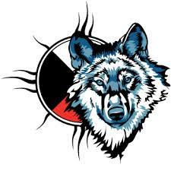Humility. The wolf carries humility. Central to the wolf is the family pack to ensure survival, the pack must be as one in one’s life, much the same as the wolf, we need to understand humility in the Wolf Pack. Each member understands its individual role. In our individual lives, humility becomes the factor which allows us to ask for guidance humbly.

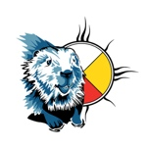Wisdom. The beaver carries wisdom. Wisdom is not to be confused with knowledge, wisdom is the gained experience, and knowledge is to know the difference and accept responsibility and accountability. When one pollutes the water, one does not break a human law but the law of nature which states that to poison the water it is to destroy oneself.
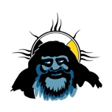Honesty. Honesty is carried by the Sabi. It is from within and not to be confused with truth. In reality there is no ifs, ands or buts, but there can only be honesty if one is to survive. In the wilderness, one either knows survival, or one does not. Presently man as a being is living on the edge simply because he is not honest with himself, he does not want to believe that what he is taking in, is toxic, Alcohol and drugs. furthermore, he is not honest with his environment, which supports him. This generation is the first to leave a legacy of destruction, literally we are feeding them upon our children…. blatant honesty.

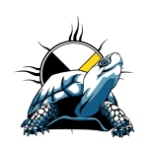Truth. The turtle carries truth. Truth is symbolic of law and principle. Since the beginning of time, the turtle has not changed. The turtle has been chosen to be the bearer of truth, and the basic truth of the laws of nature have not changed. The turtle has been able to adapt to change without changing thus, he represents truth he also represents time his shell has 13 big plates symbolizing the 13 moons in one year.

Objective:

To ensure lifelong learning by eliminating the achievement gap between the students in Elsipogtog FN and those in the province by provide opportunities and support to learners, teachers, parents, and communities.

Goals:

1) To improve students’ understanding of who they are, by revitalizing the Mikmaq language, cultural and ethical values, traditions, and history of the community
2) To improve achievement in literacy and language arts skills
3) To improve achievement in numeracy skills
4) To improve science achievement
5) To improve student attendance and retention rates through providing a school environment grounded in the values and traditions of the Mikmaq culture.

“We’re here for the kids”

